Assignment – hypothesis testing

P1. A company claims that their new energy drink increases focus and alertness.

Formulate the null and alternative hypotheses for testing this claim.

* Ans. **Null Hypothesis (H₀):** The new energy drink has no effect on focus and alertness.
* **Alternative Hypothesis (H₁):** The new energy drink increases focus and alertness.

In statistical notation, these hypotheses can be expressed as:

H0 : 𝜇=𝜇0

H1: 𝜇>𝜇0

where:

* 𝜇 represents the mean level of focus and alertness after consuming the new energy drink.
* μ0 ​ represents the mean level of focus and alertness without consuming the energy drink (or with a placebo).

If we are measuring focus and alertness through some quantifiable metric, the null hypothesis H0​ asserts that the mean score on this metric does not increase after consuming the energy drink, while the alternative hypothesis H1​ asserts that the mean score increases, indicating improved focus and alertness.

P2. A researcher is conducting a study on the effects of exercise on weight loss. What

significance level should they choose for their hypothesis test and why?

Ans. For a study on the effects of exercise on weight loss, the researcher might consider the following when choosing the significance level:

1. **Common Practice in the Field:** In many fields, especially in health and social sciences, a significance level of 0.05 (5%) is standard. This means there is a 5% chance of concluding that exercise affects weight loss when it actually does not.
2. **Consequences of Type I Error:** If concluding that exercise affects weight loss (when it does not) has relatively low consequences (e.g., people exercise more but do not lose weight), a higher significance level (e.g., 0.05) might be acceptable. However, if the consequences are more severe (e.g., significant resource allocation based on incorrect results), the researcher might choose a lower significance level (e.g., 0.01 or 0.001).
3. **Consequences of Type II Error:** Balancing the significance level with the risk of a Type II error (failing to detect a true effect) is important. A very low significance level reduces the risk of a Type I error but increases the risk of a Type II error. If it's crucial not to miss a true effect of exercise on weight loss, the researcher might be more lenient with a higher significance level.

Given these considerations, here are some typical significance levels the researcher might choose:

* **0.05 (5%)**: This is the most commonly used significance level in many research fields. It offers a balance between Type I and Type II errors and is generally accepted for studies where the consequences of Type I error are moderate.
* **0.01 (1%)**: This is a more stringent significance level, reducing the chance of a Type I error. It might be chosen if the researcher wants stronger evidence before concluding that exercise affects weight loss.
* **0.001 (0.1%)**: This level is used in cases where the consequences of a Type I error are very high, requiring very strong evidence to reject the null hypothesis.

For a typical study on the effects of exercise on weight loss, a significance level of **0.05** is generally appropriate. This level is widely accepted in health and social sciences and balances the risk of making Type I and Type II errors. However, the researcher should consider the specific context and potential consequences when making the final decision.

P3. Interpreting p-values:

- In a study investigating the effectiveness of a new teaching method, the calculated

p-value is 0.03. What does this p-value indicate about the null hypothesis?

Ans. iven the calculated p-value of 0.03 in a study investigating the effectiveness of a new teaching method, we can interpret this p-value as follows:

* **P-value = 0.03**: There is a 3% chance of observing the data, or something more extreme, if the null hypothesis is true.

To determine what this p-value indicates about the null hypothesis, we compare it to the chosen significance level (alpha, α). Common significance levels are 0.05, 0.01, and 0.001. Here are the implications based on different significance levels:

1. **If α = 0.05**:
   * Since the p-value (0.03) is less than the significance level (0.05), we reject the null hypothesis.
   * This indicates that there is sufficient evidence to suggest that the new teaching method is effective.
2. **If α = 0.01**:
   * Since the p-value (0.03) is greater than the significance level (0.01), we fail to reject the null hypothesis.
   * This indicates that there is not sufficient evidence to conclude that the new teaching method is effective at this more stringent significance level.
3. **If α = 0.001**:
   * Since the p-value (0.03) is much greater than the significance level (0.001), we fail to reject the null hypothesis.
   * This indicates that there is not sufficient evidence to conclude that the new teaching method is effective at this very stringent significance level.

In most typical research contexts where the significance level is set at 0.05, a p-value of 0.03 would lead to rejecting the null hypothesis. This suggests that there is statistically significant evidence to support the effectiveness of the new teaching method. However, the exact conclusion may vary depending on the chosen significance level and the specific requirements of the study.

P4. Type I and Type II Errors:

- Describe a scenario in which a Type I error could occur in hypothesis testing. How

does it differ from a Type II error?

### Ans. Type I and Type II Errors:

**Type I Error (False Positive)**: A Type I error occurs when the null hypothesis is true, but we incorrectly reject it. This means we conclude that there is an effect or a difference when there actually is none.

**Type II Error (False Negative)**: A Type II error occurs when the null hypothesis is false, but we fail to reject it. This means we conclude that there is no effect or difference when there actually is one.

**Scenario for Type I Error:**

**Context**: Imagine a pharmaceutical company testing a new drug designed to reduce blood pressure. The null hypothesis (H₀) is that the new drug has no effect on blood pressure, and the alternative hypothesis (H₁) is that the new drug does reduce blood pressure.

**Type I Error Scenario**:

* **Null Hypothesis (H₀):** The new drug does not reduce blood pressure.
* **Alternative Hypothesis (H₁):** The new drug reduces blood pressure.

In a clinical trial, suppose the company conducts the test and finds a p-value of 0.03, and their chosen significance level (α) is 0.05. Because 0.03 < 0.05, they reject the null hypothesis and conclude that the drug is effective in reducing blood pressure.

**Type I Error Occurs If**: In reality, the new drug does not actually reduce blood pressure (the null hypothesis is true), but the test results lead to the incorrect conclusion that it does. This error could lead to the drug being marketed and prescribed despite having no real benefit, potentially wasting resources and posing health risks.

**Scenario for Type II Error:**

**Context**: Using the same scenario of testing the new drug for reducing blood pressure:

**Type II Error Scenario**:

* **Null Hypothesis (H₀):** The new drug does not reduce blood pressure.
* **Alternative Hypothesis (H₁):** The new drug reduces blood pressure.

In another clinical trial, suppose the company conducts the test and finds a p-value of 0.08, and their chosen significance level (α) is 0.05. Because 0.08 > 0.05, they fail to reject the null hypothesis and conclude that the drug is not effective.

**Type II Error Occurs If**: In reality, the new drug does reduce blood pressure (the null hypothesis is false), but the test results lead to the incorrect conclusion that it does not. This error could prevent a beneficial drug from being available to patients who need it.

**Key Differences:**

1. **Nature of the Error**:
   * **Type I Error**: Rejecting a true null hypothesis (false positive).
   * **Type II Error**: Failing to reject a false null hypothesis (false negative).
2. **Consequences**:
   * **Type I Error**: Incorrectly concluding that there is an effect when there is none, potentially leading to unwarranted actions or treatments.
   * **Type II Error**: Incorrectly concluding that there is no effect when there is one, potentially missing out on beneficial treatments or interventions.
3. **Control**:
   * **Type I Error**: Controlled by the significance level (α), commonly set at 0.05.
   * **Type II Error**: Controlled by the power of the test (1 - β), with power typically aimed to be 0.80 or higher to minimize the risk of missing a true effect.

P5. Right-tailed Hypothesis Testing:

- A manufacturer claims that their new light bulb lasts, on average, more than 1000

hours. Conduct a right-tailed hypothesis test with a significance level of 0.05, given a

sample mean of 1050 hours and a sample standard deviation of 50 hours.

### Ans.

### 

6. Two-Tailed Hypothesis Testing:

- A researcher wants to determine if there is a difference in mean exam scores between

two groups of students. Formulate the null and alternative hypotheses for this study as a

two-tailed test.

### Ans.

**Null Hypothesis (H0​)**

The null hypothesis states that there is no difference in the mean exam scores between the two groups of students.

H0 ​: μ1​=μ2​

Where:

* μ1​ is the mean exam score of the first group of students.
* μ2 ​ is the mean exam score of the second group of students.

**Alternative Hypothesis (H1​)**

The alternative hypothesis states that there is a difference in the mean exam scores between the two groups of students.

H1 : μ1≠μ2

This is a two-tailed test because the alternative hypothesis does not specify the direction of the difference; it only states that the means are not equal.

**7. One-sample t-test:**

- A manufacturer claims that the mean weight of their cereal boxes is 500 grams. A

sample of 30 cereal boxes has a mean weight of 490 grams and a standard deviation of

20 grams. Conduct a one-sample t-test to determine if there is evidence to support the

manufacturer's claim at a significance level of 0.05.

Ans.

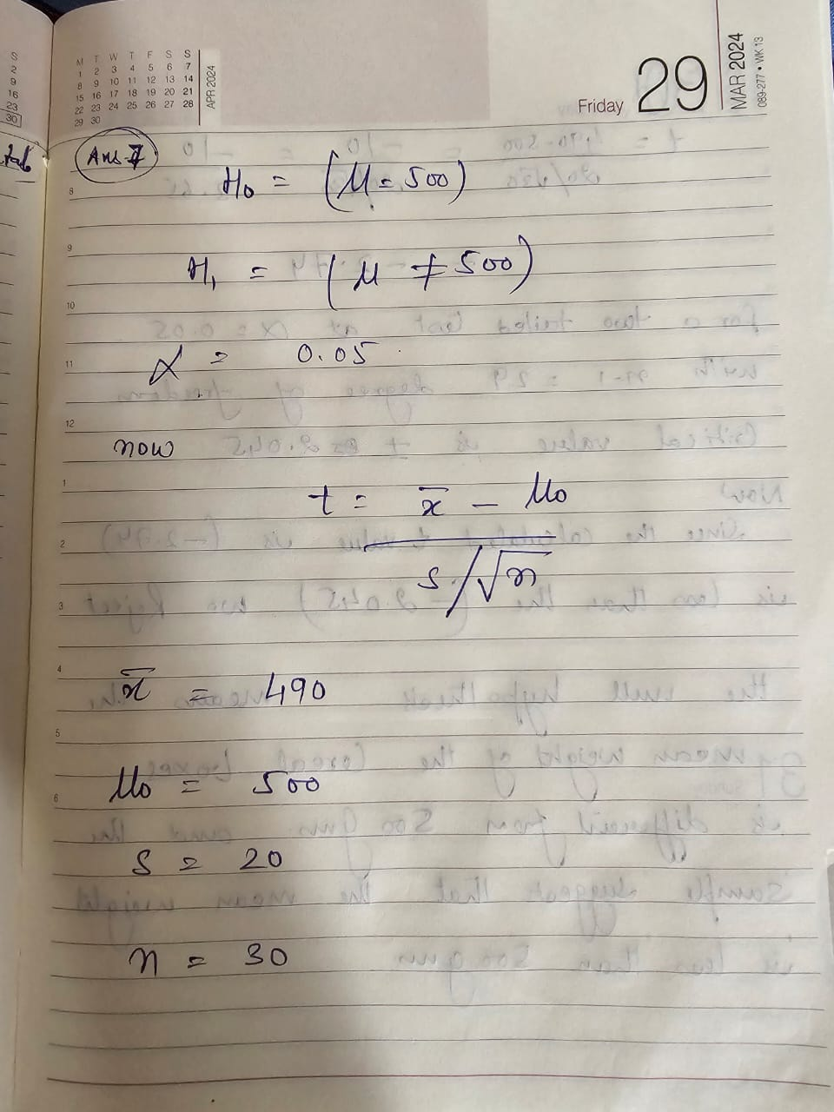

**8. Two-sample t-test:**

- A researcher wants to compare the mean reaction times of two different groups of

participants in a driving simulation study. Group A has a mean reaction time of 0.6

seconds with a standard deviation of 0.1 seconds, while Group B has a mean reaction

time of 0.55 seconds with a standard deviation of 0.08 seconds. Conduct a two-sample

t-test to determine if there is a significant difference in mean reaction times between the

groups at a significance level of 0.01

Ans.

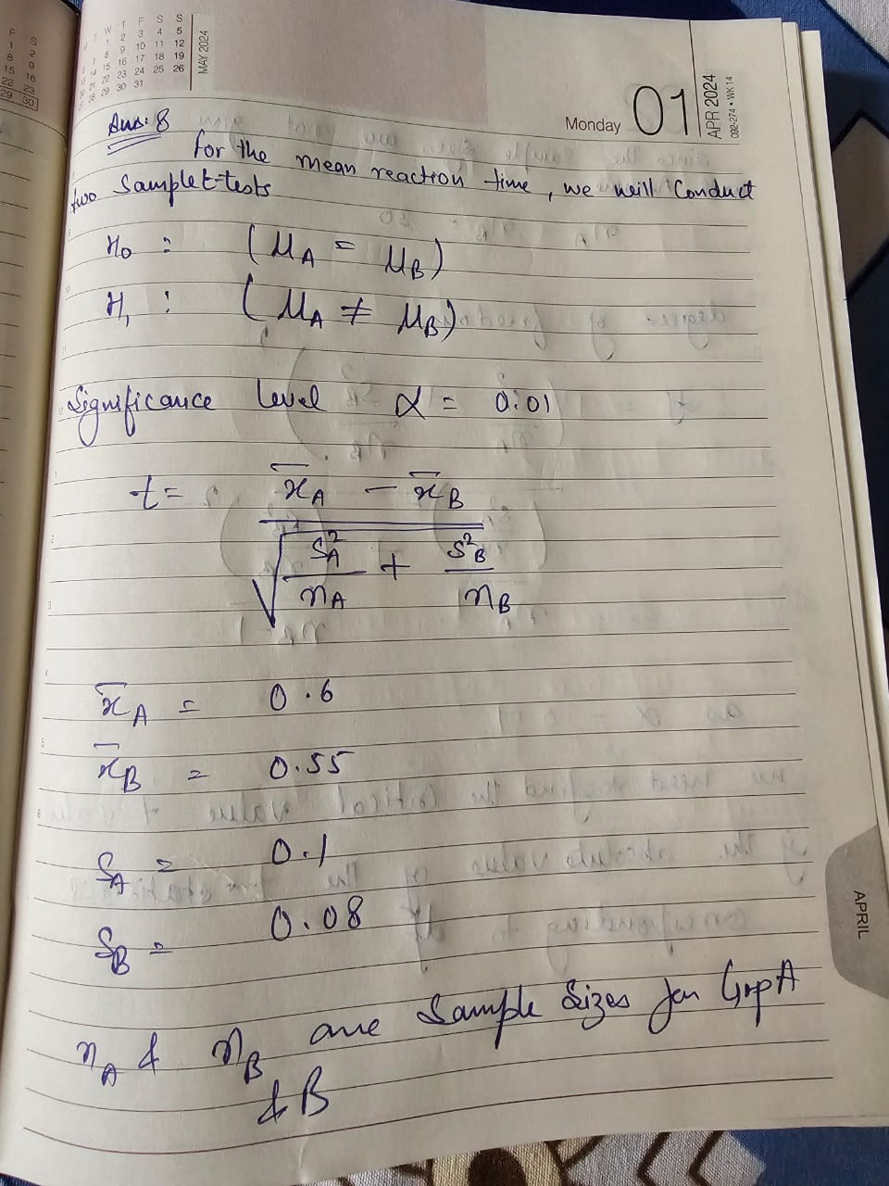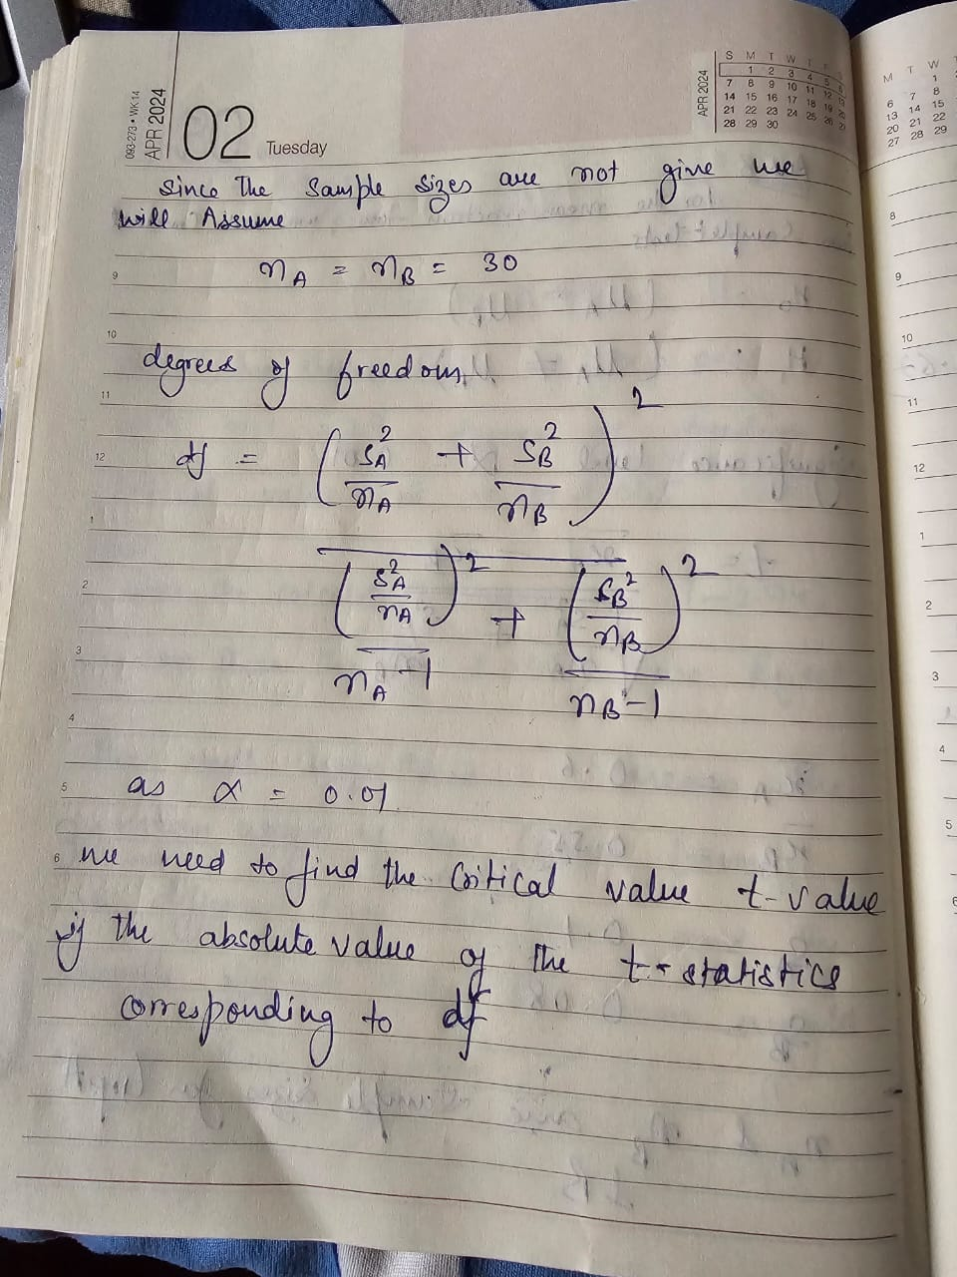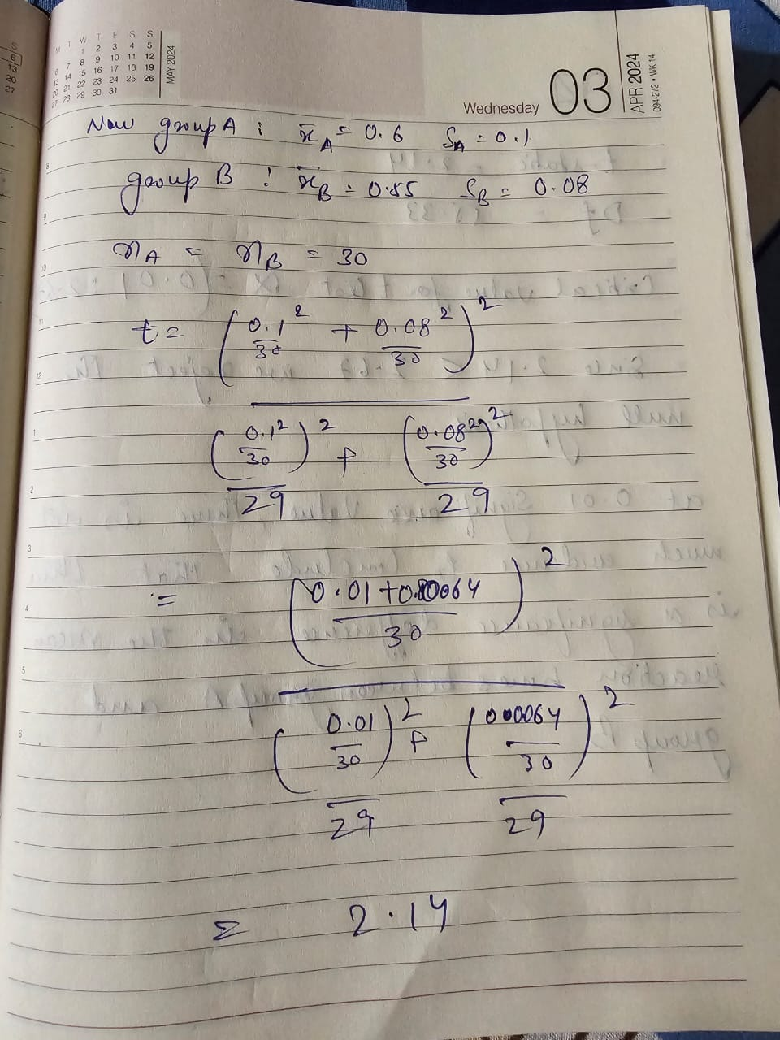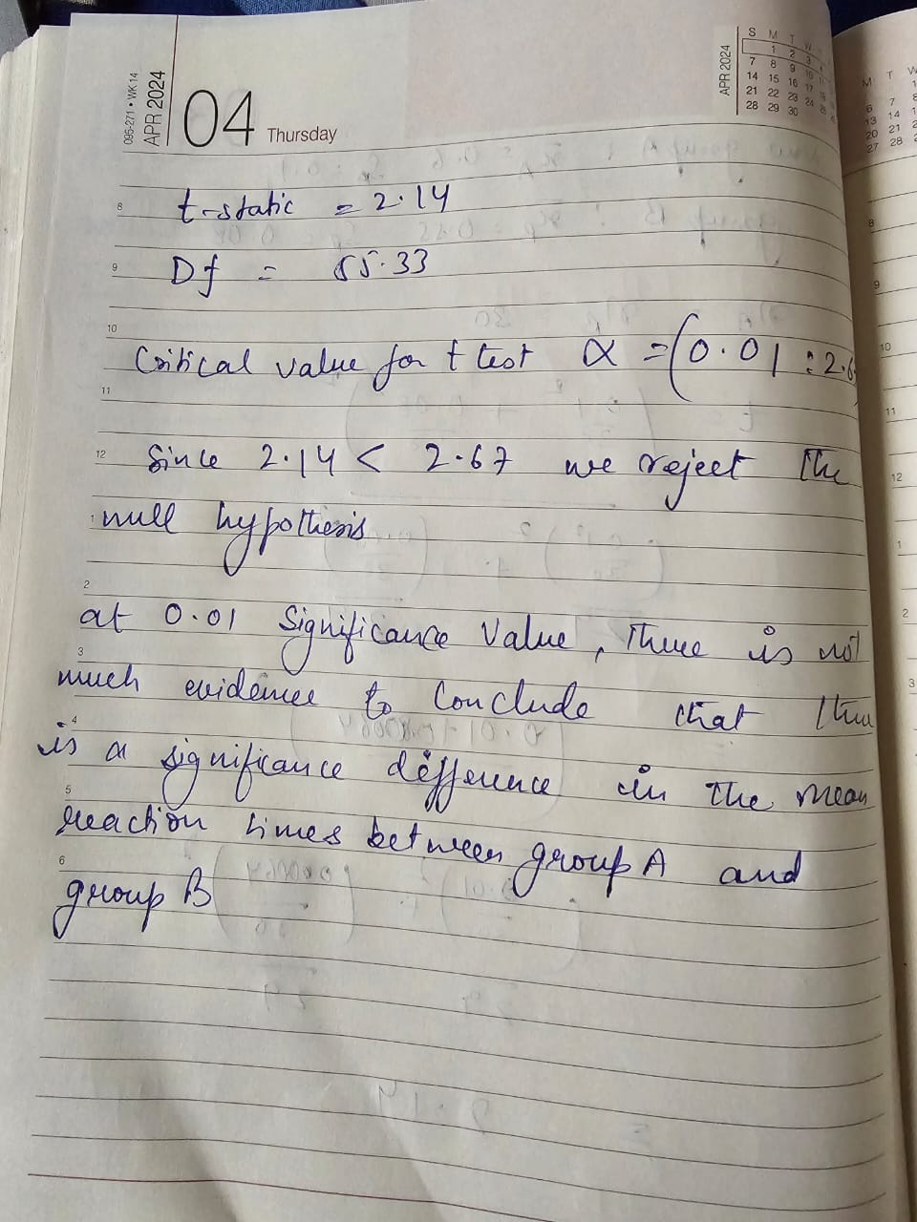

9. Process Control Example:

- A call center manager implements a new training program aimed at reducing call

waiting times. The average waiting time before the training program was 4.5 minutes, and

after the program, it is measured to be 4.0 minutes with a standard deviation of 0.8

minutes. Conduct a hypothesis test to determine if there is evidence that the training

program has reduced waiting times, using a significance level of 0.05

Ans.

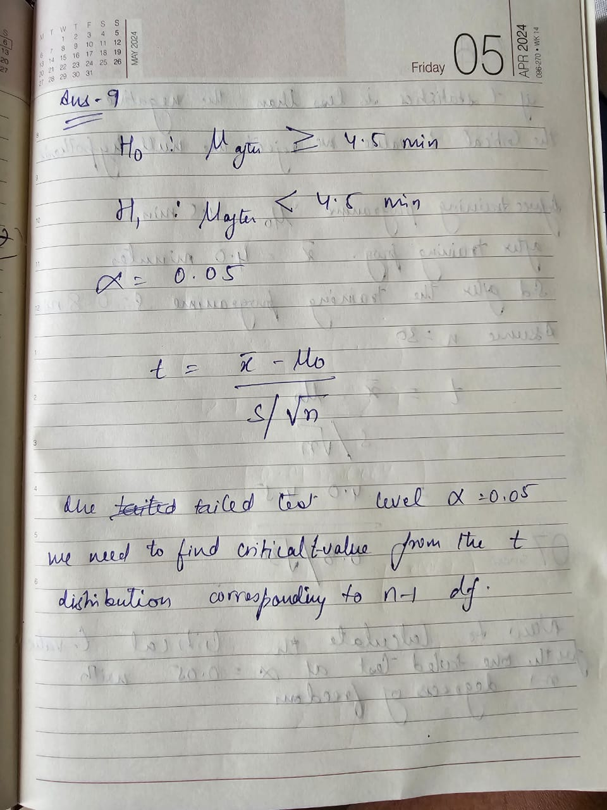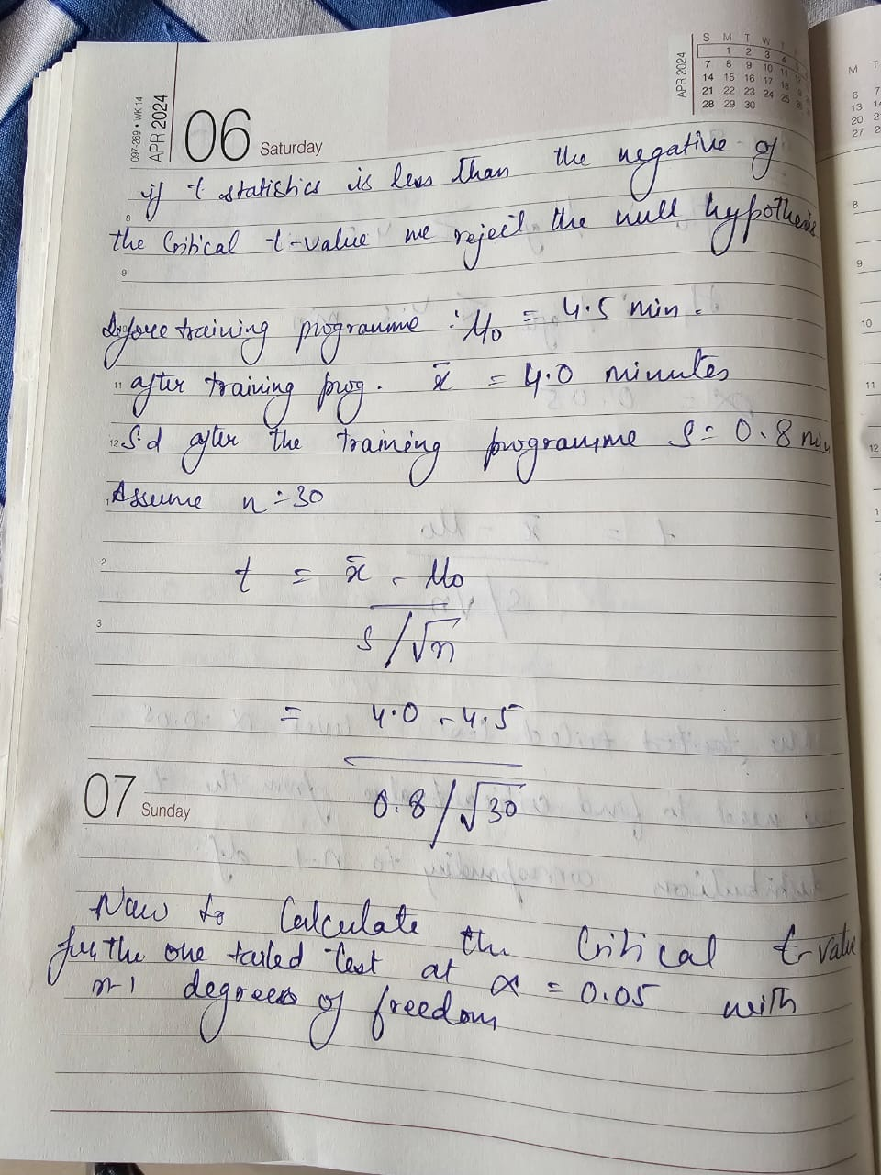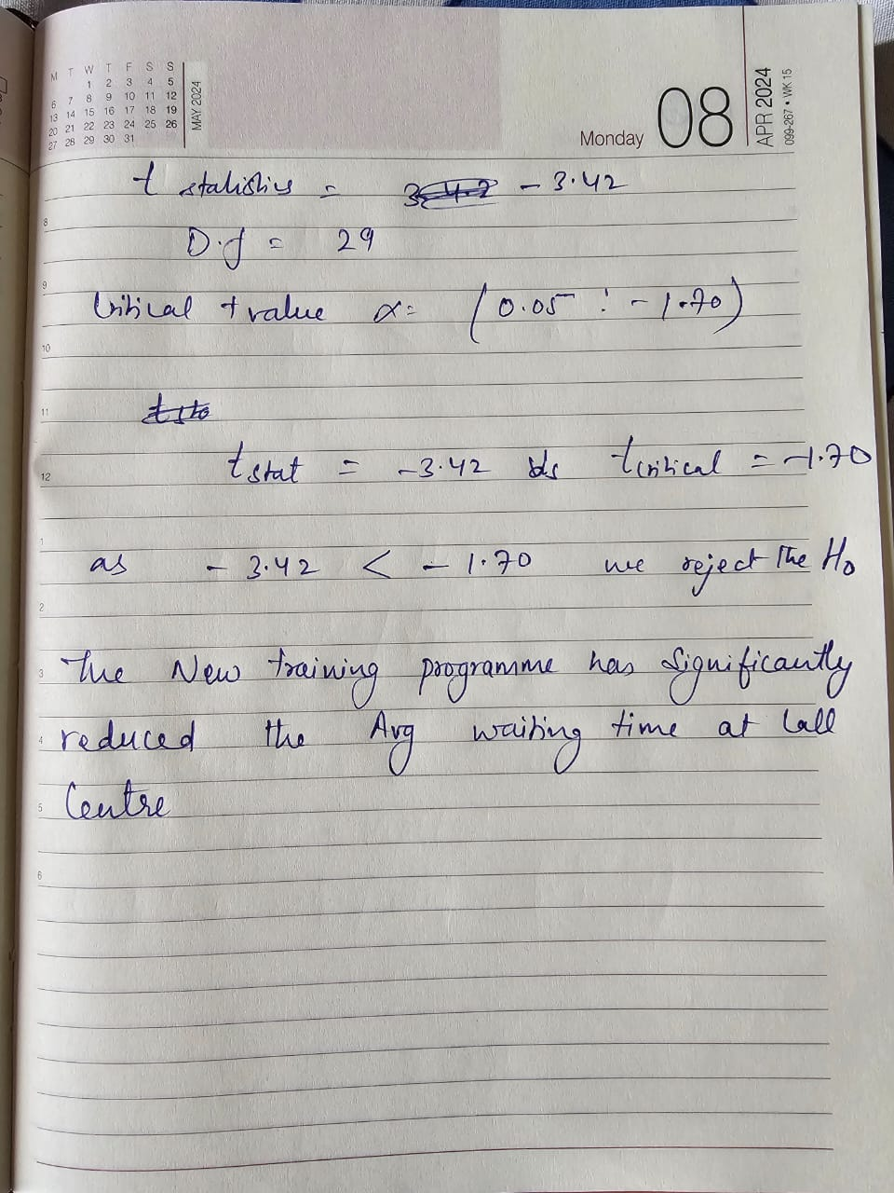

**10. Interpreting Results:**

- After conducting a hypothesis test, the calculated p-value is 0.02. What can you

conclude about the null hypothesis based on this result, assuming a significance level of

0.05?

Ans.

If the calculated p-value is 0.02 and the significance level (α) is 0.05, we can draw the following conclusion about the null hypothesis:

* If the p-value ≤ significance level (α), we reject the null hypothesis (H0​).
* If the p-value > significance level (α), we fail to reject the null hypothesis (H0​).

**Conclusion:**

Since the p-value of 0.02 is less than the significance level of 0.05, we **reject the null hypothesis**.

**Conclusion**

There is sufficient evidence to conclude that there is a significant effect or difference, which in the context of the hypothesis test implies that the new training program has significantly reduced the average waiting time.